Letter of permission

Date:

To whom it may concern,

Visit to <naam land>

First allow me to introduce myself. My name is Corine Poot, Head of the Bilingual Department at Marnix College in Ede, The Netherlands.

Marnix College is a secondary school offering general secondary education preparing students either for university or for higher professional education.
Some of our students attend a special, rather demanding bilingual course for four years in order to prepare them for working or studying abroad. Half of the lessons are taught in English, the other half in Dutch. In the fourth year of this course it is mandatory to visit an English speaking country. The pupils usually stay with relatives or with friends and are expected to write a detailed report about their stay in which they show that they have studied different aspects of the society they visited.

Therefore I would like to inform you with this letter that
……………………………………………………, aged………………………
is a student of our school and has our permission to visit …………….. in
the following period:………………………………………………

His/her temporary address is:……………………………………………………..
……………………………………………………………………………………..
…………………………………………………………………………………….

Both our school and the parents permit him/her to travel
from……………………………………. to………………………………………………….
unaccompanied.

Yours faithfully, Name parent 1:…………………………….
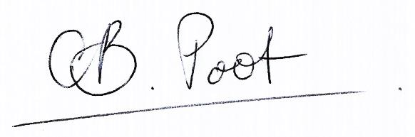
Address: :…………………………………..
Telephone: :………………………….…….
Signature:

Corine Poot
Marnix College
Prins Bernhardlaan 30 Name parent 2: :…………………...……...
NL-6713 MC Ede Address: :…………………………….…….
The Netherlands Telephone: :……………………….……….
Telephone: +31 318 650035 Signature:
Fax: +31 318 653910
Email: c.poot@marnixcollege.nl

